Broadcast

📢 What Is Broadcast in Networking?
# Source: AI Source: Provided by: [Data Path: Persons Table -> ID Column: 1, Name_En Column: Motasem Essam] -> From: [ChatGPT] on [12/18/2025]
Broadcast is a one-to-all communication method where a device sends data to all other devices on the same network segment — whether they need it or not.

📦 Belongs to:
# Source: AI Source: Provided by: [Data Path: Persons Table -> ID Column: 1, Name_En Column: Motasem Essam] -> From: [ChatGPT] on [12/18/2025]
✅ Types of Network Transmission Modes
Alongside Unicast (one-to-one) and Multicast (one-to-many)

🧠 Definition:
# Source: AI Source: Provided by: [Data Path: Persons Table -> ID Column: 1, Name_En Column: Motasem Essam] -> From: [ChatGPT] on [12/18/2025]
In broadcast, the sender transmits a message to all devices in the local network (broadcast domain).

📡 Example Use Cases:
# Source: AI Source: Provided by: [Data Path: Persons Table -> ID Column: 1, Name_En Column: Motasem Essam] -> From: [ChatGPT] on [12/18/2025]
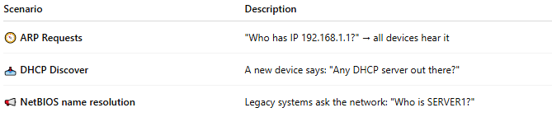
Scenario | Description
🧭 ARP Requests | "Who has IP 192.168.1.1?" → all devices hear it
📥 DHCP Discover | A new device says: "Any DHCP server out there?"
📢 NetBIOS name resolution | Legacy systems ask the network: "Who is SERVER1?"

🔢 IPv4 Broadcast Address
# Source: AI Source: Provided by: [Data Path: Persons Table -> ID Column: 1, Name_En Column: Motasem Essam] -> From: [ChatGPT] on [12/18/2025]
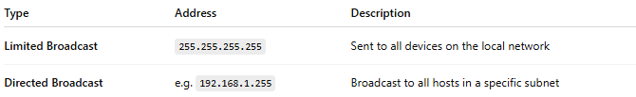
Type | Address | Description
Limited Broadcast | 255.255.255.255 | Sent to all devices on the local network
Directed Broadcast | e.g. 192.168.1.255 | Broadcast to all hosts in a specific subnet
📌 Note: IPv6 does not use broadcast. It uses multicast instead.

🧰 Characteristics
# Source: AI Source: Provided by: [Data Path: Persons Table -> ID Column: 1, Name_En Column: Motasem Essam] -> From: [ChatGPT] on [12/18/2025]
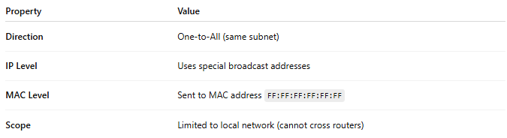
Property | Value
Direction | One-to-All (same subnet)
IP Level | Uses special broadcast addresses
MAC Level | Sent to MAC address FF:FF:FF:FF:FF:FF
Scope | Limited to local network (cannot cross routers)

✅ Advantages
# Source: AI Source: Provided by: [Data Path: Persons Table -> ID Column: 1, Name_En Column: Motasem Essam] -> From: [ChatGPT] on [12/18/2025]
- ✅ Simple way to discover services (like DHCP)
- ✅ Useful for network booting, resolution, etc.

❌ Disadvantages
# Source: AI Source: Provided by: [Data Path: Persons Table -> ID Column: 1, Name_En Column: Motasem Essam] -> From: [ChatGPT] on [12/18/2025]
- ❌ Can lead to broadcast storms in large networks
- ❌ Wastes bandwidth — all devices process the message even if not needed
- ❌ Not routable — routers block broadcast traffic by default

📋 Comparison Table
# Source: AI Source: Provided by: [Data Path: Persons Table -> ID Column: 1, Name_En Column: Motasem Essam] -> From: [ChatGPT] on [12/18/2025]
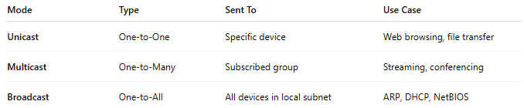
Mode | Type | Sent To | Use Case
Unicast | One-to-One | Specific device | Web browsing, file transfer
Multicast | One-to-Many | Subscribed group | Streaming, conferencing
Broadcast | One-to-All | All devices in local subnet | ARP, DHCP, NetBIOS

